PROG6221 PART 1

ST10066258

Tshedza Ramabulana

2022

Table of Contents

Link to GitHub respiratory 2

Link Screenshot of code running 2

Link to GitHub Respiratory 3

# Link to GitHub respiratory

<https://github.com/IIEMSA/prog6221-part2-Tshedza2001>

# Link Screenshot of code running

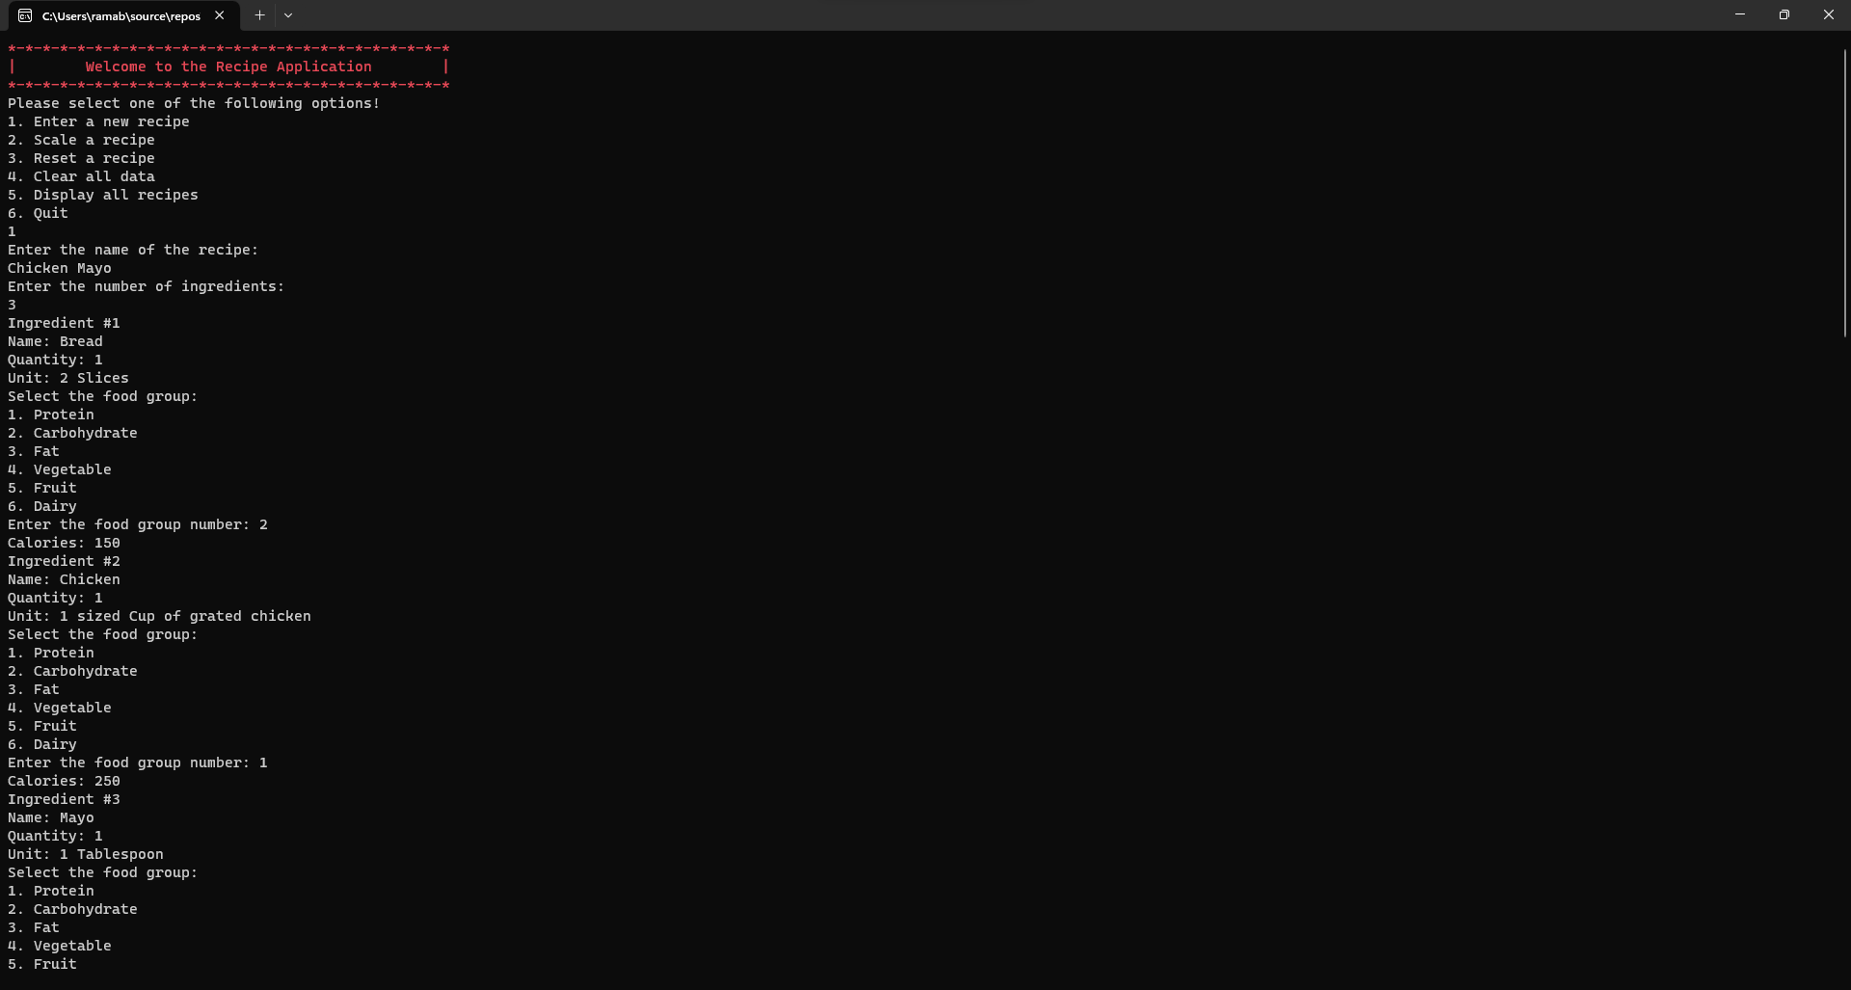

# Link to GitHub Respiratory

